**2nd IoT, Big Data Healthcare Summit Western Canada**

When: November 28-29, 2017   
Where: Vancouver, BC

**EVENT DETAILS:**

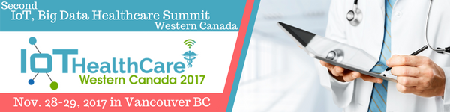

The Deputy Chief Medical Officer of **First Nations Health Authority**, Dr. Shannon McDonald, and Kim Heath, PharmD, Medication Safety Coordinator of **TriStar Centennial Medical Center in Nashville, Tennessee** have recently been confirmed to join the amazing speaker line-up at this conference.

**SPEAKERS INCLUDE:**

* CCIO, Fraser Health Authority
* Deputy Chief Medical Officer, First Nations Health Authority
* Executive Director & Provincial Health Analytics Officer, Alberta Health
* Executive Director of Education, Technology & Innovation, University Health Network
* Executive VP, PHSA & BC Emergency Health Services
* Chair, Medical Director, Health Data Coalition
* **... and many, many more!**

[**Download the conference brochure**](https://iotevents.ca/healthcare-west-2-brochure/?utm_source=bchimps&utm_medium=email2&utm_campaign=healthwnov2017) **for full speaker overview and the agenda.**

BCHIMPS members get 20% off registration with code BCHIMPS

**Only a few spots left, so book now!**Please go to the website for registration: [**CONFERENCE WEBSITE**](https://iotevents.ca/event/healthcare-west-2/?utm_source=bchimps&utm_medium=email2&utm_campaign=healthwnov2017)

Sponsors: BD, Portal724, ForeScout

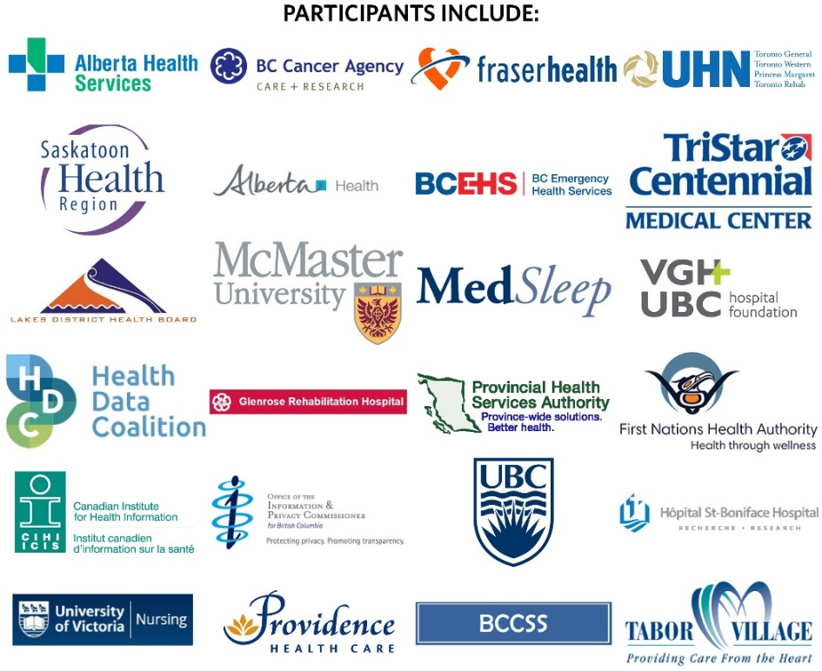  
Best regards,  
BCHIMPS